**ITE1002 WEB TECHNOLOGIES DA2**

**Prof.: Vijayan R.**

**Student name: Binayak Bishnu (20BIT0155)**

**Team members:**

1. Bhavya Vaid (20BIT0178)
2. Chetan Shiraguppi(20BIT0116)

**Project name: BookRev – Online bookstore**

**Modules used:**

1. Module 1: HTML, CSS for **structure and style**
2. Module 2:
   1. Javascript, JSON, jquery, regex for **form validation and other functionalities**
   2. Responsivity using **‘%’ and MediaQueries**
3. Module 3: AngularJS for **form validation**
4. Module 4: AJAX with JSON, used to **generate random quotes**
5. Module 5:
   1. Nodejs, Expressjs to run the **whole application and routing between pages** along with **exchanging data with database (MongoDB) and accepting form information**
   2. Sessions to **count the number of times page was visited**
6. Module 6: MongoDB to **store user data and sold books data**

**Short Description:**

A lot of readers and especially people who are new to reading are always looking to explore various genres and different books that are part of them. Our website “BookRev” provides just that.

Various genres with various books are available for the user to go through, with special attention to people who are just beginning to read, by providing categories such as “easy reads”. Being a website that revolves around books, we have also provided users to sell and buy old books according to their choice.

The website provides a clean navigation beginning with a login page where you can either create a new account or login. This is followed by a landing page with random quotes to freshen you minds.

This is followed by a explore page that had various cards for each genre. Each card leads to list of book in that genre. The book cards in turn lead to pages specifically made for each book.

We also have a sell page where users can upload details and samples for selling books and a buy page to buy books.

**Source Code**

**server.js**

const express = require('express');

const bodyParser = require('body-parser');

const path = require('path');

const MongoClient = require('mongodb').MongoClient;

const cookieParser = require('cookie-parser');

const session = require('express-session')

const app = express()

app.use(cookieParser());

app.use(session({ secret: "secret" }));

const u = bodyParser.urlencoded({ extended: false })

app.use(express.static(path.join(__dirname, 'html')))

app.use(express.static(path.join(__dirname, 'css')))

app.use(express.static(path.join(__dirname, 'assets')))

app.get('/', (req, res) => {

    res.sendFile(path.join(__dirname, 'index.html'))

})

app.use(function (req, res, next) {

    var cookie = req.cookies.cookieName;

    if (req.session.page) {

        req.session.page++;

        console.log('navigated', req.session.page - 1, 'times');

    }

    else {

        req.session.page = 1;

    }

    next();

});

app.post('/reg', u, function (req, res) {

    var response = {

        name: req.body.signupmail,

        password: req.body.signuppass

    }

    MongoClient.connect('mongodb://localhost:27017/', function (err, db) {

        if (err)

            throw err;

        else

            console.log("mongo connected!")

        var dbo = db.db("base1");

        dbo.collection('users').insertOne(response);

    })

    res.sendFile(path.join(__dirname, 'index.html'))

})

app.post('/log', u, (req, res) => {

    var re = {

        name: req.body.loginmail,

        password: req.body.loginpass

    }

    MongoClient.connect('mongodb://localhost:27017/', function (err, db) {

        if (err)

            throw err;

        else

            console.log("mongo connected!")

        var dbo = db.db("base1");

        dbo.collection("users").find(re).toArray(function (err, result) {

            if (err)

                throw err

            else if (result.length == 0) {

                res.sendFile(path.join(__dirname, 'index.html'))

            }

            else {

                res.sendFile(path.join(__dirname, './html/landing.html'))

            }

        })

    })

})

app.get('/rememberme', (req, res) => {

    res.sendFile(path.join(__dirname, './html/explore_subpages/fiction_rememberme.html'))

})

app.get('/alchemist', (req, res) => {

    res.sendFile(path.join(__dirname, './html/explore_subpages/fiction_alchemist.html'))

})

app.get('/writtenstars', (req, res) => {

    res.sendFile(path.join(__dirname, './html/explore_subpages/fiction_stars.html'))

})

app.post('/sell', u, function (req, res) {

    var response = {

        name: req.body.name,

        description: req.body.desc,

        cost: req.body.cost,

        sellprice: req.body.sellprice,

        contact: req.body.phone,

        bookpic: req.body.fileupload,

    }

    MongoClient.connect('mongodb://localhost:27017/', function (err, db) {

        if (err)

            throw err;

        else

            console.log("mongo connected!")

        var dbo = db.db("base2");

        dbo.collection('sell').insertOne(response);

    })

    res.sendFile(path.join(__dirname, './html/sellalert.html'))

})

app.post('/gohome', function (req, res) {

    res.sendFile(path.join(__dirname, './html/landing.html'))

})

app.listen(3000, () => {

    console.log('BookRev server running!')

})

**index.html**

<!DOCTYPE html>

<html lang="en">

<head>

    <meta charset="UTF-8">

    <meta http-equiv="X-UA-Compatible" content="IE=edge">

    <meta name="viewport" content="width=device-width, initial-scale=1.0">

    <link rel="stylesheet" type="text/css" href="index_styles.css">

    <title>BookRev - Login</title>

    <script src="https://ajax.googleapis.com/ajax/libs/jquery/3.3.1/jquery.min.js"></script>

</head>

<body>

    <div class="login-container">

        <div class="login-form">

            <div id="welcome" align="center">

                <h1>Welcome to BookRev!</h1>

            </div>

            <div class="toggle">

                <div id="selected-btn"></div>

                <button type="button" class="toggle-button" onclick="Transition1()">Login</button>

                <button type="button" class="toggle-button" onclick="Transition2()">Sign up</button>

            </div><br><br>

            <form id="login" class="credentials" method="POST" action="/log">

                <label>Email</label>

                <input type="email" name="loginmail" class="input" required><br><br>

                <label>Password</label>

                <input type="password" name="loginpass" class="input" required><br><br>

                <button type="submit" class="submit-btn">Login</button><br><br>

                <button class="Home">Home</button>

            </form>

            <form name= "form1" id="sign-up" class="credentials" method="POST" action="/reg">

                <label>Email</label>

                <input type="email" name="signupmail" class="input" id="SignEmail" required><br><br>

                <label>Password</label>

                <input type="password" name="signuppass" class="input" id="SignPass" required><br>

                <label>Confirm password</label>

                <input type="password" class="input" id="SignConPass" required><br>

                <button type="button" class="submit-btn" id="sign-up-submit">Sign up</button>

            </form>

        </div>

    </div>

    <script>

        let a = document.getElementById("login");

        let b = document.getElementById("sign-up");

        let c = document.getElementById("selected-btn");

        function Transition2() {

            a.style.left = "-400px";

            b.style.left = "50px";

            c.style.right = "0px";

            c.style.left = "auto";

        }

        function Transition1() {

            a.style.left = "50px";

            b.style.left = "450px";

            c.style.left = "0px";

            c.style.right = "auto";

        }

        // Jquery implementation

        $(function () {

            $("#sign-up-submit").click(function () {

                let p = $("#SignPass").val();

                let q = $("#SignConPass").val();

                let w = $("#SignEmail").val();

                const re = /^(([^<>()[\]\\.,;:\s@"]+(\.[^<>()[\]\\.,;:\s@"]+)*)|(".+"))@((\[[0-9]{1,3}\.[0-9]{1,3}\.[0-9]{1,3}\.[0-9]{1,3}\])|(([a-zA-Z\-0-9]+\.)+[a-zA-Z]{2,}))$/;

                if (!re.test(String(w).toLowerCase())) {

                    alert("Enter a valid Email address!")

                }

                else {

                    if (p != q && p != "")

                        alert("Passwords do not match!");

                    if (p == q && q != "")

                    form1.submit();

            }});

        });

        $(function(){

            $(".home").click(function(){

                document.location.href="/landing.html";

            })

        })

    </script>

</body>

</html>

**index_style.css**

* {

    margin: 0;

    padding: 0;

}

body{

    background-image: url("books_bg.jpg");

    background-position: center;

    background-size:cover;

}

#welcome{

    margin-top:8%;

}

.login-container{

    position:block;

}

.login-form {

    width: 380px;

    height: 480px;

    position: relative;

    margin: 6% auto;

    background: #ffffff;

    padding: 5px;

    border-radius: 20px;

    overflow: hidden;

}

#login{

    left: 50px;

    display:flex;

    flex-direction: column;

    align-items: flex-start;

    justify-content:space-between;

}

#sign-up{

    left: 450px;

    display:flex;

    flex-direction: column;

    align-items: flex-start;

    justify-content:space-between;

}

.toggle {

    position: relative;

    margin: 35px auto;

    box-shadow: 0 0 20px 9px #5144ff1f;

    border-radius: 30px;

    display: flex;

    justify-content: space-between;

    width: 62%;

}

.toggle-button {

    padding: 10px 30px;

    cursor: pointer;

    background: transparent;

    border: 0;

    outline: none;

    position: relative;

    width: 45%;

    margin: 0%;

}

#selected-btn {

    position: absolute;

    width: 110px;

    height: 100%;

    background: linear-gradient(to right, rgb(140, 138, 255), rgb(140, 138, 255));

    border-radius: 30px;

    transition: all 1s linear;

}

.credentials {

    position: absolute;

    top: 180px;

    width: 280px;

    transition: 0.5s;

}

.input {

    width: 100%;

    padding: 5px 5px;

    outline: none;

    background: transparent;

    border-radius: 10px;

}

.submit-btn {

    width: 85%;

    padding: 10px 30px;

    cursor: pointer;

    display: block;

    margin: auto;

    background: linear-gradient(to right, hsl(241, 100%, 77%), hsl(241, 100%, 77%));

    border: none;

    border-radius: 10px;

}

.Home{

    width: 85%;

    padding: 10px 30px;

    cursor: pointer;

    display: block;

    margin: auto;

    background: linear-gradient(to right, hsl(241, 100%, 77%), hsl(241, 100%, 77%));

    border: none;

    border-radius: 10px;

}

**landing.html**

<!DOCTYPE html>

<html lang="en">

<head>

  <meta charset="UTF-8">

  <meta http-equiv="X-UA-Compatible" content="IE=edge">

  <meta name="viewport" content="width=device-width, initial-scale=1.0">

  <title>BookRev - Home</title>

  <link rel="stylesheet" href="landing_styles.css">

</head>

<body>

  <div id="show">

    <header>

      <nav class='cf'>

        <ul class='cf'>

          <li class="logo">

            <a href='landing.html'>

              <b>BookRev.</b>

            </a>

          </li>

          <li>

            <a href='landing.html'>Home</a>

          </li>

          <li>

            <a href='explore.html'>Explore</a>

          </li>

          <li>

            <a href='sell.html'>Sell</a>

          </li>

          <li>

            <a href='buy.html'>Buy</a>

          </li>

          <!-- <li class="right">

            <a href='../index.html'>Sign-in/up</a>

          </li> -->

        </ul>

        <a href='#' id='openup'>MENU</a>

      </nav>

    </header>

  </div>

  <div>

    <div class="content">

      <h1>Welcome to <br> BookRev.</h1>

      <h3 class="textcontent textcontenthead" style="color: rgb(177, 144, 184);" class="text"><b>If you are new to reading, or just want to explore

          genres</b>

        <br />this is your place to be!!</h3>

      <div class="text textcontent">

        <div class="quote-text">

          <h3 id="quote">

            Generate a random book quote by clicking here!

          </h3>

        </div>

        <button id="clkbtn" onclick="loadJSON()" onmouseover="func()">

          click here

        </button>

      </div>

    </div>

    <div class="img">

      <img src="read1.png" alt="illustration">

    </div>

  </div>

  <script src="data.js"></script>

  <script src="https://code.jquery.com/jquery-3.6.0.min.js"

    integrity="sha256-/xUj+3OJU5yExlq6GSYGSHk7tPXikynS7ogEvDej/m4=" crossorigin="anonymous"></script>

  <script src="../landing.js"></script>

  <script>

    function func() {

      document.getElementById("clkbtn").style.backgroundColor = "purple";

    }

  </script>

</body>

</html>

**landing_styles.css**

#clkbtn {

  width: 80px;

  height: 40px;

  border-radius: 20px;

  background-color: rgb(177, 144, 184);

  text-align: center;

}

body {

  background-color: #eee;

  margin: 0;

}

.img {

  float: right;

  padding-top: 6%;

}

.content {

  float: left;

  padding-top: 10%;

  margin-left: 5%;

  width: 40%;

}

.text {

  margin-left: 0%;

}

h1 {

  font-size: 4em;

  font-family: cursive;

  line-height: 1.1;

  text-align: center;

}

nav {

  width: 100vw;

  background-color: rgb(177, 144, 184);

  color: #ffffff;

  padding-left: 2%;

}

nav ul {

  padding: 0;

  margin: 0;

}

nav li {

  display: inline;

  float: left;

}

nav a {

  display: inline-block;

  width: 100px;

  text-align: center;

  text-decoration: none;

  padding: 10%;

  padding-left: 0%;

  color: #eee;

  text-decoration: none;

}

nav li:hover {

  background-color: rgb(214, 200, 214);

}

nav a#openup {

  display: none;

}

@media screen and (max-width: 768px) {

  .img {

    float: right;

    padding-top: 6%;

  }

  .content {

    float: left;

    padding-top: 10%;

    margin-left: 0%;

    width: 100%;

  }

  .text {

    margin-left: 0%;

  }

  .textcontent {

    padding-left: 5%;

  }

}

@media screen and (max-width: 590px) {

  .img {

    float: none;

    padding-top: 6%;

  }

  .content {

    padding-top: 10%;

    margin-left: 0%;

    width: 100%;

  }

  .text {

    margin-left: 4%;

  }

  h1 {

    font-size: 2.8em;

  }

  nav {

    height: auto;

    border-bottom: 0;

  }

  nav ul {

    display: none;

    height: auto;

  }

  nav li {

    width: 100%;

    float: left;

    position: relative;

  }

  nav a {

    text-align: left;

    width: 100%;

    padding: 2%;

  }

  nav a:hover {

    background: #444;

  }

  nav a#openup:after {

    content: "|||";

    transform: rotate(-90deg);

    -ms-transform: rotate(-90deg);

    -webkit-transform: rotate(-90deg);

    width: 30px;

    height: 30px;

    display: inline-block;

    position: absolute;

    right: 5px;

    top: 20px;

  }

  nav a#openup {

    display: block;

    background-color: rgb(214, 200, 214);

    width: 100%;

    position: relative;

  }

}

.cf:before,

.cf:after {

  content: "";

  display: table;

}

.cf:after {

  clear: both;

}

.cf {

  zoom: 1;

}

@media screen and (max-width: 400px) {

  h1 {

    font-size: 2.8em;

  }

  nav {

    height: auto;

    border-bottom: 0;

  }

  nav ul {

    display: none;

    height: auto;

  }

  nav li {

    width: 100%;

    float: left;

    position: relative;

  }

  nav a {

    text-align: left;

    width: 100%;

    background: rgb(177, 144, 184);

  }

  nav a:hover {

    background: #444;

  }

  nav a#openup:after {

    content: "|||";

    transform: rotate(-90deg);

    -ms-transform: rotate(-90deg);

    -webkit-transform: rotate(-90deg);

    width: 30px;

    height: 30px;

    display: inline-block;

    position: absolute;

    right: 5px;

    top: 20px;

  }

  nav a#openup {

    display: block;

    width: 100%;

    position: relative;

  }

}

**landing.js**

$(function () {

  menu = $('nav ul');

  $('#openup').on('click', function (e) {

    e.preventDefault(); menu.slideToggle();

  });

  $(window).resize(function () {

    var w = $(this).width(); if (w > 480 && menu.is(':hidden')) {

      menu.removeAttr('style');

    }

  });

  $('nav li').on('click', function (e) {

    var w = $(window).width(); if (w < 480) {

      menu.slideToggle();

    }

  });

  $('.open-menu').height($(window).height());

});

// function sell() {

//   document.getElementById("sell").style.Color = "black";

// }

**data.js [get data from json for quotes]**

function loadJSON(){

    var dfile="data.json"

    var data= new XMLHttpRequest();

    data.onreadystatechange= function(){

        if(data.readyState == 4 && data.status == 200)

        {

            var quotes=JSON.parse(data.responseText);

            var number=Math.floor(Math.random()*quotes.length);

            quote.html='<span>"</span>'+quotes[number].quote+'<span>"</span>';

            document.getElementById("quote").innerHTML=quotes[number];

        }

    }

    data.open('GET',dfile,true);

    data.send();

    }

**data.json [quotes]**

["Whatever our souls are made of, his and mine are the same.","It matters not what someone is born, but what they grow to be.","All we have to decide is what to do with the time that is given us."]

**explore.html**

<!DOCTYPE html>

<html lang="en">

<head>

    <meta charset="UTF-8">

    <meta http-equiv="X-UA-Compatible" content="IE=edge">

    <meta name="viewport" content="width=device-width, initial-scale=1.0">

    <link href="https://cdn.jsdelivr.net/npm/bootstrap@5.1.1/dist/css/bootstrap.min.css" rel="stylesheet"

        integrity="sha384-F3w7mX95PdgyTmZZMECAngseQB83DfGTowi0iMjiWaeVhAn4FJkqJByhZMI3AhiU" crossorigin="anonymous">

    <link rel="stylesheet" type="text/css" href="explore_styles.css">

    <title>BookRev - Explore</title>

</head>

<body>

    <div id="show">

        <header>

            <nav class='cf'>

                <ul class='cf'>

                    <li class="logo">

                        <a href='landing.html'>

                            <b>BookRev.</b>

                        </a>

                    </li>

                    <li>

                        <a href='landing.html'>Home</a>

                    </li>

                    <li>

                        <a href='explore.html'>Explore</a>

                    </li>

                    <li>

                        <a href='sell.html'>Sell</a>

                    </li>

                    <li>

                        <a href='buy.html'>Buy</a>

                    </li>

                    <!-- <li class="right">

                        <a href='../index.html'>Sign-in/up</a>

                    </li> -->

                </ul>

                <a href='#' id='openup'>MENU</a>

            </nav>

        </header>

    </div>

    <div class="container event_parent">

        <div class="row row-col-1 row-cols-lg-3 row-cols-md-2 row-cols-sm-1">

            <a href="explore_subpages/fiction.html">

                <div class="col-md">

                    <!-- Column -->

                    <div id="fiction" class="cards">

                        <h3>Fiction</h3>

                    </div>

                </div>

            </a>

            <a href="explore_subpages/easy_reads.html">

                <div class="col-md">

                    <!-- Column -->

                    <div id="beginner" class="cards">

                        <h3>Easy reads</h3>

                    </div>

                </div>

            </a>

            <a href="explore_subpages/nonfiction.html">

                <div class="col-md">

                    <!-- Column -->

                    <div id="nonfiction" class="cards">

                        <h3>Non Fiction</h3>

                    </div>

                </div>

            </a>

            <div class="col-md">

                <!-- Column -->

                <div id="scifi" class="cards">

                    <h3>Science Fiction</h3>

                </div>

            </div>

            <div class="col-md">

                <!-- Column -->

                <div id="cfiction" class="cards">

                    <h3>Crime Fiction</h3>

                </div>

            </div>

            <div class="col-md">

                <!-- Column -->

                <div id="thriller" class="cards">

                    <h3>Thiller</h3>

                </div>

            </div>

            <div class="col-md">

                <!-- Column -->

                <div id="poetry" class="cards">

                    <h3>Poetry</h3>

                </div>

            </div>

            <div class="col-md">

                <!-- Column -->

                <div id="fantasy" class="cards">

                    <h3>Fantasy</h3>

                </div>

            </div>

            <div class="col-md">

                <!-- Column -->

                <div id="romance" class="cards">

                    <h3>Romance</h3>

                </div>

            </div>

            <div class="col-md">

                <!-- Column -->

                <div id="horror" class="cards">

                    <h3>Horror</h3>

                </div>

            </div>

            <div class="col-md">

                <!-- Column -->

                <div id="drama" class="cards">

                    <h3>Drama</h3>

                </div>

            </div>

            <div class="col-md">

                <!-- Column -->

                <div id="suspense" class="cards">

                    <h3>Suspense</h3>

                </div>

            </div>

            <div class="col-md">

                <!-- Column -->

                <div id="mythology" class="cards">

                    <h3>Mythology</h3>

                </div>

            </div>

            <div class="col-md">

                <!-- Column -->

                <div id="spirituality" class="cards">

                    <h3>Spirituality</h3>

                </div>

            </div>

            <div class="col-md">

                <!-- Column -->

                <div id="histfiction" class="cards">

                    <h3>History Fiction</h3>

                </div>

            </div>

        </div>

    </div>

</body>

</html>

**explore_styles.css**

body {

  margin: 0%;

  padding: 0%;

  background-color: rgba(97, 43, 223, 0.7);

}

#welcome {

  margin-top: 2%;

  display: -webkit-box;

  display: -ms-flexbox;

  display: flex;

  -ms-flex-line-pack: center;

  align-content: center;

  -webkit-box-pack: center;

  -ms-flex-pack: center;

  justify-content: center;

  color: black;

}

.container {

  margin-top: 4%;

  padding: 0%;

}

.col-md {

  height: 300px;

  display: -webkit-box;

  display: -ms-flexbox;

  display: flex;

  -webkit-box-orient: vertical;

  -webkit-box-direction: normal;

  -ms-flex-direction: column;

  flex-direction: column;

  -webkit-box-pack: center;

  -ms-flex-pack: center;

  justify-content: center;

  -webkit-box-align: center;

  -ms-flex-align: center;

  align-items: center;

  margin: 0%;

  padding: 0%;

}

.col-md div {

  background-color: purple;

  height: 90%;

  width: 50%;

  display: -webkit-box;

  display: -ms-flexbox;

  display: flex;

  -webkit-box-orient: vertical;

  -webkit-box-direction: normal;

  -ms-flex-direction: column;

  flex-direction: column;

  -webkit-box-align: center;

  -ms-flex-align: center;

  align-items: center;

  margin: 0%;

  padding: 5% 1%;

}

.col-md div h3 {

  font-size: calc(1em + 0.5em);

  text-align: center;

  margin: 0%;

  padding: 0% 5%;

  color: black;

  background-color: rgba(255, 255, 255, 0.8);

  border-radius: 10px;

}

a {

  text-decoration: none;

  padding: 0%;

  margin: 0%;

}

#beginner {

  background-image: url("beginner.jpg");

  background-repeat: no-repeat;

  background-size: 200%;

}

#fiction {

  background-image: url("booklights.jpg");

  background-repeat: no-repeat;

  background-position: center;

  background-size: 270%;

}

.cards {

  border-radius: 10px;

}

#nonfiction {

  background-image: url("nonfiction.jpg");

  background-repeat: no-repeat;

  background-position: center;

  background-size: 250%;

}

#scifi {

  background-image: url("scifi.jpg");

  background-repeat: no-repeat;

  background-position: center;

  background-size: 150%;

}

#cfiction {

  background-image: url("crimefiction.jpg");

  background-repeat: no-repeat;

  background-position: center;

  background-size: 300%;

}

#thriller {

  background-image: url("thriller.jpg");

  background-repeat: no-repeat;

  background-position: center;

  background-size: 280%;

}

nav {

  width: 100%;

  background-color: #b190b8;

  color: #ffffff;

  padding-left: 2%;

}

nav ul {

  padding: 0;

  margin: 0;

}

nav li {

  display: inline;

  float: left;

}

nav a {

  display: inline-block;

  width: 100px;

  text-align: center;

  text-decoration: none;

  padding: 10px 0;

  color: #ffffff;

  text-decoration: none;

}

nav a:hover {

  background-color: #d6c8d6;

  color: white !important;

}

nav a#openup {

  display: none;

}

@media screen and (max-width: 590px) {

  .content {

    padding-top: 50px;

    padding-left: 25%;

  }

  img {

    width: 70%;

    padding-top: 10px;

    padding-right: 200000px;

  }

  h1 {

    font-size: 2.8em;

  }

  nav {

    height: auto;

    border-bottom: 0;

  }

  nav ul {

    display: none;

    height: auto;

  }

  nav li {

    width: 100%;

    float: left;

    position: relative;

  }

  nav a {

    text-align: left;

    width: 100%;

    text-indent: 25px;

    background: #b190b8;

    border-bottom: 1px solid #7c358a;

  }

  nav a:hover {

    background: #444;

  }

  nav a#openup:after {

    content: "|||";

    transform: rotate(-90deg);

    -ms-transform: rotate(-90deg);

    /* IE 9 */

    -webkit-transform: rotate(-90deg);

    /* Safari and Chrome */

    width: 30px;

    height: 30px;

    display: inline-block;

    position: absolute;

    right: 5px;

    top: 20px;

  }

  nav a#openup {

    display: block;

    background-color: #d6c8d6;

    width: 100%;

    position: relative;

  }

}

.cf:before,

.cf:after {

  content: "";

  display: table;

}

.cf:after {

  clear: both;

}

.cf {

  zoom: 1;

}

@media screen and (max-width: 1199px) {

  #fiction {

    background-size: 300%;

  }

  #nonfiction {

    background-size: 300%;

  }

}

@media screen and (max-width: 576px) {

  #welcome {

    margin-top: 8%;

  }

  .container {

    margin-top: 8%;

    width: 80%;

  }

  #fiction {

    background-size: 300%;

  }

  #nonfiction {

    background-size: 300%;

  }

}

**Explore subpages**

**finction.html**

<!DOCTYPE html>

<html lang="en">

<head>

    <meta charset="UTF-8">

    <meta http-equiv="X-UA-Compatible" content="IE=edge">

    <meta name="viewport" content="width=device-width, initial-scale=1.0">

    <link href="https://cdn.jsdelivr.net/npm/bootstrap@5.1.1/dist/css/bootstrap.min.css" rel="stylesheet"

        integrity="sha384-F3w7mX95PdgyTmZZMECAngseQB83DfGTowi0iMjiWaeVhAn4FJkqJByhZMI3AhiU" crossorigin="anonymous">

    <link rel="stylesheet" type="text/css" href="explore_subpages.css">

    <title>Book Rev - Fiction</title>

    <style>

        #gopage {

            border: 0px;

            background-color: rgba(0, 0, 0, 0);

        }

    </style>

</head>

<body>

    <!-- <a href="../explore.html" id="goback">&lt Go back</a> -->

    <h1 id="genrename" style="font-family: cursive; text-align: center;color: white; font-weight: bold;">

        Fiction</h1>

    <section id="booklist">

        <div class="booklistmember booklistmember2">

            <img src="fiction2.jpg" class="booklistmemberimg" width="100%" />

            <div class="booklistmembercontent">

                <h3>

                    <!-- <a href="fiction_rememberme.html">Remember me</a> -->

                    <form name="rememberme" id="rememberme" class="rememberme" method="GET" action="/rememberme">

                        <input type="submit" name="remembermebtn" value="Remember Me" id="gopage" />

                    </form>

                </h3>

                <p>At the height of the Spanish Civil War, 500 children are shipped to Mexico to escape the bloody

                    violence. The intent was to bring them back at the war's end, but when WWII hits, the children are

                    left stranded away from their family and the only home they ever knew.</p>

            </div>

        </div>

        <div class="booklistmember booklistmember3">

            <img src="fiction3.jpg" class="booklistmemberimg" />

            <div class="booklistmembercontent">

                <h3>

                    <form name="alchemist" id="alchemist" class="alchemist" method="GET" action="/alchemist">

                        <input type="submit" name="alchemistbtn" value="The Alchemist" id="gopage" />

                    </form>

                </h3>

                <p>

                    This story, dazzling in its powerful simplicity and soul-stirring wisdom, is about an Andalusian

                    shepherd boy named Santiago, who travels from his homeland in Spain to the Egyptian desert in search

                    of a treasure buried near the Pyramids.

                </p>

            </div>

        </div>

        <div class="booklistmember booklistmember1">

            <img src="fiction1.png" class="booklistmemberimg" />

            <div class="booklistmembercontent">

                <h3>

                    <form name="writtenstars" id="writtenstars" class="writtenstars" method="GET"

                        action="/writtenstars">

                        <input type="submit" name="writtenstarsbtn" value="Written in the Stars" id="gopage" />

                    </form>

                </h3>

                <p>

                    Written in the Stars, by debut novelist Alexandria Bellefleur, is a queer romance about two women

                    with opposing life goals and very different personalities who stumble into a fake relationship that

                    should've come with a warning: Love is right around the corner, just you wait and see!

                </p>

            </div>

        </div>

    </section>

</body>

</html>

**easyreads.html**

<!DOCTYPE html>

<html lang="en">

<head>

    <meta charset="UTF-8">

    <meta http-equiv="X-UA-Compatible" content="IE=edge">

    <meta name="viewport" content="width=device-width, initial-scale=1.0">

    <link href="https://cdn.jsdelivr.net/npm/bootstrap@5.1.1/dist/css/bootstrap.min.css" rel="stylesheet"

        integrity="sha384-F3w7mX95PdgyTmZZMECAngseQB83DfGTowi0iMjiWaeVhAn4FJkqJByhZMI3AhiU" crossorigin="anonymous">

    <link rel="stylesheet" type="text/css" href="explore_subpages.css">

    <title>Book Rev - Easy Reads</title>

</head>

<body>

    <!-- <a href="../explore.html" id="goback">&lt Go back</a> -->

    <h1 id="genrename" style="font-family: cursive; text-align: center;color: white; font-weight: bold;">

        Easy Reads</h1>

    <section id="booklist">

        <div class="booklistmember booklistmember1">

            <img src="easy_read1.jpg" class="booklistmemberimg" />

            <div class="booklistmembercontent">

                <h3>Elephants cannot dance!</h3>

                <p>In this humorous outing, Gerald the elephant and Piggie debate whether or not "elephants can dance."

                    Gerald, who is convinced that he cannot (he tells Piggie to look it up in the "What Elephants Can

                    Do" book) decides to give it a go nonetheless. Results are mixed, with Gerald basically doing the

                    opposite of each instruction. Willems's characteristically sparse cartoon images and the use of

                    speech balloons portray the comical dilemma with clarity, making it an ideal pick for early readers.

                </p>

            </div>

        </div>

        <div class="booklistmember booklistmember2">

            <img src="easy_read2.jpg" class="booklistmemberimg" />

            <div class="booklistmembercontent">

                <h3>Poof! A bot!</h3>

                <p>Zip has zapped a bot. Zip tells the bot what to do. Will the bot listen? Perfect for kids at the

                    beginning of their reading journeys, Poof! A Bot! was written for children

                    who have learned the alphabet and are ready to start reading!</p>

            </div>

        </div>

        <div class="booklistmember booklistmember3">

            <img src="easy_read3.jpg" class="booklistmemberimg" />

            <div class="booklistmembercontent">

                <h3>Hey, Tabby Cat!</h3>

                <p>Designed specifically to help young children learning to read, this book contains four stories

                    charting the adventures of Tabby Cat.</p>

            </div>

        </div>

    </section>

</body>

</html>

**nonfiction.html**

<!DOCTYPE html>

<html lang="en">

<head>

    <meta charset="UTF-8">

    <meta http-equiv="X-UA-Compatible" content="IE=edge">

    <meta name="viewport" content="width=device-width, initial-scale=1.0">

    <link href="https://cdn.jsdelivr.net/npm/bootstrap@5.1.1/dist/css/bootstrap.min.css" rel="stylesheet"

        integrity="sha384-F3w7mX95PdgyTmZZMECAngseQB83DfGTowi0iMjiWaeVhAn4FJkqJByhZMI3AhiU" crossorigin="anonymous">

    <link rel="stylesheet" type="text/css" href="explore_subpages.css">

    <title>Book Rev - Non Fiction</title>

</head>

<body>

    <!-- <a href="../explore.html" id="goback">&lt Go back</a> -->

    <h1 id="genrename" style="font-family: cursive; text-align: center;color: white; font-weight: bold;">

        Non-Fiction</h1>

    <section id="booklist">

        <div class="booklistmember booklistmember2">

            <img src="nonfiction1.jpeg" class="booklistmemberimg" />

            <div class="booklistmembercontent">

                <h3>Black and British</h3>

                <p></p>

            </div>

        </div>

        <div class="booklistmember booklistmember3">

            <img src="nonfiction2.jpg" class="booklistmemberimg" />

            <div class="booklistmembercontent">

                <h3>I am Malala</h3>

                <p></p>

            </div>

        </div>

        <div class="booklistmember booklistmember1">

            <img src="nonfiction3.jpg" class="booklistmemberimg" />

            <div class="booklistmembercontent">

                <h3>Midnight in Chernobyl</h3>

                <p></p>

            </div>

        </div>

    </section>

</body>

</html>

**explore_subpages.css**

body {

    margin: 0%;

    padding: 0%;

    background-image: url("books_bg.jpg");

    background-size: cover;

}

#welcome {

    margin-top: 2%;

    display: flex;

    align-content: center;

    justify-content: center;

    color: black;

}

#genrename {

    margin-top: 2%;

    margin-bottom: 5%;

}

.booklistmember {

    width: 90%;

    margin: 2% auto;

    border: 2px solid black;

    border-radius:20px;

    padding: 1% 5%;

    background-color: rgb(204, 191, 216);

    display: flex;

    flex-direction: row;

    justify-content: flex-start;

    align-items: flex-start;

}

.booklistmembercontent {

    margin-top: 2%;

    margin-left: 5%;

}

.booklistmemberimg {

    width: 15%;

}

**Fiction book pages**

**fiction_rememberme.html**

<!DOCTYPE html>

<html lang="en">

<head>

    <meta charset="UTF-8">

    <meta http-equiv="X-UA-Compatible" content="IE=edge">

    <meta name="viewport" content="width=device-width, initial-scale=1.0">

    <title>Remember Me</title>

    <link href="https://cdn.jsdelivr.net/npm/bootstrap@5.1.3/dist/css/bootstrap.min.css" rel="stylesheet"

        integrity="sha384-1BmE4kWBq78iYhFldvKuhfTAU6auU8tT94WrHftjDbrCEXSU1oBoqyl2QvZ6jIW3" crossorigin="anonymous">

    <script src="https://cdn.jsdelivr.net/npm/bootstrap@5.1.3/dist/js/bootstrap.bundle.min.js"

        integrity="sha384-ka7Sk0Gln4gmtz2MlQnikT1wXgYsOg+OMhuP+IlRH9sENBO0LRn5q+8nbTov4+1p"

        crossorigin="anonymous"></script>

    <script type="text/javascript" src="http://code.jquery.com/jquery-latest.min.js"></script>

    <style>

        body {

            background-image: url("../explore_subpages/remembermebg.jpeg");

            background-size: cover;

            background-repeat: no-repeat;

        }

        body:before {

            content: "";

            display: block;

            position: fixed;

            width: 100%;

            height: 100%;

            left: 0;

            top: 0;

            z-index: -1;

            background-color: rgba(255, 255, 255, 0.6);

        }

        .container {

            display: flex;

            flex-direction: column;

            justify-content: flex-start;

            align-items: center;

            padding: 4%;

        }

        .imgdesp {

            padding: 0%;

            padding-top: 5%;

            margin: 0%;

            /* display: flex;

            flex-direction: row;

            justify-content: center;

            align-items: flex-start; */

            display: grid;

            grid-template-columns: 2fr 9fr;

            grid-template-rows: 1fr 1fr;

            column-gap: 5%;

        }

        img {

            grid-row-start: 1;

            grid-row-end: 3;

        }

        .bigdesp {

            grid-column-start: 1;

            grid-column-end: 3;

            padding-top: 5%;

        }

    </style>

</head>

<body>

    <div class="container">

        <h1 style="font-family: cursive; font-weight: bold;">Remember Me<br /><i>A Spanish Civil War Novel by Mario

                Escobar</i></h1>

        <div class="imgdesp">

            <img src="fiction2.jpg" class="booklistmemberimg" width="100%" />

            <div style="background-color:rgba(131, 169, 158,0.6); height:fit-content; padding:0%; border-radius: 20px;">

                <p style="padding:2%; margin:0%;">

                    <i>

                        "At the height of the Spanish Civil War, 500 children are shipped to Mexico to escape the bloody

                        violence. The intent was to bring them back at the war's end, but when WWII hits, the children

                        are

                        left stranded away from their family and the only home they ever knew."

                    </i>

                </p>

            </div>

            <div>

                <table cellpadding="6px" cellspacing="0">

                    <thead>

                        <tr>

                            <th>Quantity</th>

                            <td>

                                <input type="number" name="quantity" id="quantity" value=0 min=1 style="width:25%" />

                            </td>

                            <td>

                                <input

                                    style="background-color: rgba(12,12,12,0.3);border:2px solid black;border-radius: 10px;"

                                    type="submit" name="quantitybtn" value="Go" onclick="go()" />

                            </td>

                        </tr>

                        <tr>

                            <th>Price</th>

                            <td><span id="price">0</span></td>

                            <td>

                                <input

                                    style="background-color: rgba(12,12,12,0.3);border:2px solid black;border-radius: 10px;"

                                    type="submit" name="addtocart" value="Add to cart" onclick="cart()" />

                            </td>

                        </tr>

                        <tr>

                            <th>Stock:</th>

                            <td id="stock">65</td>

                        </tr>

                    </thead>

                </table>

            </div>

            <p class="bigdesp">

                Amid the shadows of war, one family faces an impossible choice that will change their lives forever.

                From bestseller Mario Escobar comes a 20th-century historical novel of sacrifice and resilience inspired

                by Spain’s famed Children of Morelia and the true events that shaped their lives.

                Madrid, 1934. Though the Spanish Civil War has not yet begun, the streets of Madrid have become

                dangerous for thirteen-year-old Marco Alcalde and his two younger sisters. Marco’s parents align

                themselves against the new fascist regime, unaware that their choice will endanger the entire family—nor

                do they predict the violence that is to come.

                In a desperate bid for safety, the Alcaldes join many other Spanish families in making an impossible

                choice to send their unaccompanied children across the ocean to the city of Morelia, Mexico—a place

                they’ve never seen or imagined, but whose government promises their children protection. Young Marco

                promises to look after his sisters in Mexico until their family can be reunited in Spain, but a

                harrowing journey ensues.

                As the growing children work to care for themselves and each other, they feel their sense of home,

                family, and identity slipping further and further away. As their memories of Spain fade, they begin to

                wonder if they will ever see their parents again or the glittering streets of the home they once loved.

                Based upon the true stories of the Children of Morelia, Mario Escobar’s Remember Me—now available for

                the first time in English—paints a poignant portrait of an immigrant family’s sacrificial love and

                endurance, detailing just how far we go for those we love.

                “Luminous and beautifully researched, Remember Me is a study of displacement, belonging, compassion, and

                forged family amid a heart- wrenching escape from the atrocities of the Spanish Civil War. Fans of

                Arturo Pérez-Reverte, Chanel Cleeton, and Lisa Wingate will be mesmerized.” —Rachel McMillan, author of

                The London Restoration

            </p>

        </div>

    </div>

    <script type="text/javascript">

        function go() {

            var Q = document.getElementById("quantity").value;

            // console.log(Q);

            document.getElementById("price").innerHTML = Q * 110;

        }

        function cart() {

            var Q = document.getElementById("quantity").value;

            // console.log(Q);

            document.getElementById("stock").innerHTML -= Q;

            document.getElementById("quantity").value = 0;

            document.getElementById("price").innerHTML = 0;

        }

    </script>

</body>

</html>

**fiction_alchemist.html**

<!DOCTYPE html>

<html lang="en">

<head>

    <meta charset="UTF-8">

    <meta http-equiv="X-UA-Compatible" content="IE=edge">

    <meta name="viewport" content="width=device-width, initial-scale=1.0">

    <title>The Alchemist</title>

    <link href="https://cdn.jsdelivr.net/npm/bootstrap@5.1.3/dist/css/bootstrap.min.css" rel="stylesheet"

        integrity="sha384-1BmE4kWBq78iYhFldvKuhfTAU6auU8tT94WrHftjDbrCEXSU1oBoqyl2QvZ6jIW3" crossorigin="anonymous">

    <script src="https://cdn.jsdelivr.net/npm/bootstrap@5.1.3/dist/js/bootstrap.bundle.min.js"

        integrity="sha384-ka7Sk0Gln4gmtz2MlQnikT1wXgYsOg+OMhuP+IlRH9sENBO0LRn5q+8nbTov4+1p"

        crossorigin="anonymous"></script>

    <script type="text/javascript" src="http://code.jquery.com/jquery-latest.min.js"></script>

    <style>

        body {

            /* background: url("remembermebg.jpeg"); */

            background-image: url("../explore_subpages/alchemistbg.jpg");

            background-size: cover;

            background-repeat: no-repeat;

        }

        body:before {

            content: "";

            display: block;

            position: fixed;

            width: 100%;

            height: 100%;

            left: 0;

            top: 0;

            z-index: -1;

            background-color: rgba(255, 255, 255, 0.6);

        }

        .container {

            display: flex;

            flex-direction: column;

            justify-content: flex-start;

            align-items: center;

            padding: 4%;

        }

        .imgdesp {

            padding: 0%;

            padding-top: 5%;

            margin: 0%;

            /* display: flex;

            flex-direction: row;

            justify-content: center;

            align-items: flex-start; */

            display: grid;

            grid-template-columns: 2fr 9fr;

            grid-template-rows: 1fr 1fr;

            column-gap: 5%;

        }

        img {

            grid-row-start: 1;

            grid-row-end: 3;

        }

        .bigdesp {

            grid-column-start: 1;

            grid-column-end: 3;

            padding-top: 5%;

        }

    </style>

</head>

<body>

    <div class="container">

        <h1 style="font-family: cursive; font-weight: bold;">The Alchemist<br /><i>A Fable about following your

                dream</i></h1>

        <div class="imgdesp">

            <img src="fiction3.jpg" class="booklistmemberimg" width="100%" />

            <div style="background-color:rgba(251, 183, 74, 0.6); height:fit-content; padding:0%; border-radius: 20px;">

                <p style="padding:2%; margin:0%;">

                    <i>

                        "This story, dazzling in its powerful simplicity and soul-stirring wisdom, is about an

                        Andalusian

                        shepherd boy named Santiago, who travels from his homeland in Spain to the Egyptian desert in

                        search

                        of a treasure buried near the Pyramids."

                    </i>

                </p>

            </div>

            <div>

                <table cellpadding="6px" cellspacing="0">

                    <thead>

                        <tr>

                            <th>Quantity</th>

                            <td>

                                <input type="number" name="quantity" id="quantity" value=0 min=1 style="width:25%" />

                            </td>

                            <td>

                                <input

                                    style="background-color: rgba(12,12,12,0.3);border:2px solid black;border-radius: 10px;"

                                    type="submit" name="quantitybtn" value="Go" onclick="go()" />

                            </td>

                        </tr>

                        <tr>

                            <th>Price</th>

                            <td><span id="price">0</span></td>

                            <td>

                                <input

                                    style="background-color: rgba(12,12,12,0.3);border:2px solid black;border-radius: 10px;"

                                    type="submit" name="addtocart" value="Add to cart" onclick="cart()" />

                            </td>

                        </tr>

                        <tr>

                            <th>Stock:</th>

                            <td id="stock">61</td>

                        </tr>

                    </thead>

                </table>

            </div>

            <p class="bigdesp">

                The Alchemist tells the story of a young shepherd named Santiago who is able to find a treasure beyond

                his wildest dreams. Along the way, he learns to listen to his heart and, more importantly, realizes that

                his dreams, or his Personal Legend, are not just his but part of the Soul of the Universe.

                Santiago is a humble shepherd whose desires are few–he wants to be free to roam with his sheep, to have

                some wine in his wineskin and a book in his bag. Fate intervenes, however, in the form of the recurring

                dream of a great treasure hidden thousands of miles away at the base of the Egyptian Pyramids. When

                Santiago meets Melchizedek, a strange wise man who claims he is a king from a far-off land, he decides

                to seek his treasure. The next day, Santiago sells his sheep and embarks to Africa to pursue his dream.

            </p>

        </div>

    </div>

    <script type="text/javascript">

        function go() {

            var Q = document.getElementById("quantity").value;

            // console.log(Q);

            document.getElementById("price").innerHTML = Q * 100;

        }

        function cart() {

            var Q = document.getElementById("quantity").value;

            // console.log(Q);

            document.getElementById("stock").innerHTML -= Q;

            document.getElementById("quantity").value = 0;

            document.getElementById("price").innerHTML = 0;

        }

    </script>

</body>

</html>

**fiction_stars.html**

<!DOCTYPE html>

<html lang="en">

<head>

    <meta charset="UTF-8">

    <meta http-equiv="X-UA-Compatible" content="IE=edge">

    <meta name="viewport" content="width=device-width, initial-scale=1.0">

    <title>Written in the Stars</title>

    <link href="https://cdn.jsdelivr.net/npm/bootstrap@5.1.3/dist/css/bootstrap.min.css" rel="stylesheet"

        integrity="sha384-1BmE4kWBq78iYhFldvKuhfTAU6auU8tT94WrHftjDbrCEXSU1oBoqyl2QvZ6jIW3" crossorigin="anonymous">

    <script src="https://cdn.jsdelivr.net/npm/bootstrap@5.1.3/dist/js/bootstrap.bundle.min.js"

        integrity="sha384-ka7Sk0Gln4gmtz2MlQnikT1wXgYsOg+OMhuP+IlRH9sENBO0LRn5q+8nbTov4+1p"

        crossorigin="anonymous"></script>

    <script type="text/javascript" src="http://code.jquery.com/jquery-latest.min.js"></script>

    <style>

        body {

            /* background: url("remembermebg.jpeg"); */

            background-image: url("../explore_subpages/starsbg.jpg");

            background-size: cover;

            background-repeat: no-repeat;

        }

        body:before {

            content: "";

            display: block;

            position: fixed;

            width: 100%;

            height: 100%;

            left: 0;

            top: 0;

            z-index: -1;

            background-color: rgba(255, 255, 255, 0.6);

        }

        .container {

            display: flex;

            flex-direction: column;

            justify-content: flex-start;

            align-items: center;

            padding: 4%;

        }

        .imgdesp {

            padding: 0%;

            padding-top: 5%;

            margin: 0%;

            /* display: flex;

            flex-direction: row;

            justify-content: center;

            align-items: flex-start; */

            display: grid;

            grid-template-columns: 2fr 9fr;

            grid-template-rows: 1fr 1fr;

            column-gap: 5%;

        }

        img {

            grid-row-start: 1;

            grid-row-end: 3;

        }

        .bigdesp {

            grid-column-start: 1;

            grid-column-end: 3;

            padding-top: 5%;

        }

    </style>

</head>

<body>

    <div class="container">

        <h1 style="font-family: cursive; font-weight: bold;">Written in the Stars<br /><i>A Fable about following your

                dream</i></h1>

        <div class="imgdesp">

            <img src="fiction1.png" class="booklistmemberimg" width="100%" />

            <div style="background-color:rgba(17, 73, 135, 0.6); height:fit-content; padding:0%; border-radius: 20px;">

                <p style="padding:2%; margin:0%;">

                    <i>

                        "Realistic fiction that will change your life"

                    </i>

                </p>

            </div>

            <div>

                <table cellpadding="6px" cellspacing="0">

                    <thead>

                        <tr>

                            <th>Quantity</th>

                            <td>

                                <input type="number" name="quantity" id="quantity" value=0 min=1 style="width:25%" />

                            </td>

                            <td>

                                <input

                                    style="background-color: rgba(12,12,12,0.3);border:2px solid black;border-radius: 10px;"

                                    type="submit" name="quantitybtn" value="Go" onclick="go()" />

                            </td>

                        </tr>

                        <tr>

                            <th>Price</th>

                            <td><span id="price">0</span></td>

                            <td>

                                <input

                                    style="background-color: rgba(12,12,12,0.3);border:2px solid black;border-radius: 10px;"

                                    type="submit" name="addtocart" value="Add to cart" onclick="cart()" />

                            </td>

                        </tr>

                        <tr>

                            <th>Stock:</th>

                            <td id="stock">40</td>

                        </tr>

                    </thead>

                </table>

            </div>

            <p class="bigdesp">

                Written in the Stars, by debut novelist Alexandria Bellefleur, is a queer romance about two women with

                opposing life goals and very different personalities who stumble into a fake relationship that should've

                come with a warning: Love is right around the corner, just you wait and see!

            </p>

        </div>

    </div>

    <script type="text/javascript">

        function go() {

            var Q = document.getElementById("quantity").value;

            document.getElementById("price").innerHTML = Q * 120;

        }

        function cart() {

            var Q = document.getElementById("quantity").value;

            // console.log(Q);

            document.getElementById("stock").innerHTML -= Q;

            document.getElementById("quantity").value = 0;

            document.getElementById("price").innerHTML = 0;

        }

    </script>

</body>

</html>

**sell.html**

<!DOCTYPE html>

<html lang="en">

<head>

  <meta charset="UTF-8">

  <meta http-equiv="X-UA-Compatible" content="IE=edge">

  <meta name="viewport" content="width=device-width, initial-scale=1.0">

  <title>BookRev - Sell</title>

  <!-- <link href="https://cdn.jsdelivr.net/npm/bootstrap@5.1.1/dist/css/bootstrap.min.css" rel="stylesheet"

    integrity="sha384-F3w7mX95PdgyTmZZMECAngseQB83DfGTowi0iMjiWaeVhAn4FJkqJByhZMI3AhiU" crossorigin="anonymous"> -->

  <script src="https://code.jquery.com/jquery-3.6.0.min.js"

    integrity="sha256-/xUj+3OJU5yExlq6GSYGSHk7tPXikynS7ogEvDej/m4=" crossorigin="anonymous"></script>

  <!-- <script src="../landing.js"></script> -->

</head>

<body>

  <div id="show">

    <header>

      <nav class='cf'>

        <ul class='cf'>

          <li class="logo">

            <a href='landing.html'>

              <b>BookRev.</b>

            </a>

          </li>

          <li>

            <a href='landing.html'>Home</a>

          </li>

          <li>

            <a href='explore.html'>Explore</a>

          </li>

          <li>

            <a href='sell.html'>Sell</a>

          </li>

          <li>

            <a href='buy.html'>Buy</a>

          </li>

          <!-- <li class="right">

            <a href='../index.html'>Sign-in/up</a>

          </li> -->

        </ul>

      </nav>

    </header>

  </div>

  <!--WebTech!-->

  <script src="http://ajax.googleapis.com/ajax/libs/angularjs/1.4.9/angular.min.js"></script>

  <link rel="stylesheet" href="https://cdnjs.cloudflare.com/ajax/libs/font-awesome/4.7.0/css/font-awesome.min.css">

  <link rel="stylesheet" href="sell.css">

  <div class="main">

    <div class="formcss">

      <div ng-app="" class="cen">

        <form name="myForm" id="formcss" method="POST" action="/sell">

          <h1><u>Enter details of the book to be sold</u></h1>

          <label style="font-size: 1.2em;"><b>Name of the book:</b></label>

          <input type="text" class="input" name="name" ng-model="name" pattern="[a-zA-Z ]{1,}" required><br>

          <span ng-show="myForm.$submitted || myForm.name.$dirty">

            <span class="error" ng-show="myForm.name.$error.required"><i class="fa fa-exclamation-circle"></i> Name

              Required</span>

            <span class="error" ng-show="myForm.name.$error.pattern"><i class="fa fa-exclamation-circle"></i> Name

              cannot be Number</span>

          </span><br><br>

          <label style="font-size: 1.2em;"><b>Short Description:</b></label>

          <textarea name="desc" class="binput" ng-model="desc" pattern="[a-zA-Z ]{1,}" required></textarea><br>

          <span ng-show="myForm.$submitted || myForm.desc.$dirty">

            <span class="error" ng-show="myForm.desc.$error.required"><i class="fa fa-exclamation-circle"></i>

              Description required</span>

            <span class="error" ng-show="myForm.desc.$error.pattern"><i class="fa fa-exclamation-circle"></i>

              Description should only contain letters</span>

          </span><br><br>

          <label style="font-size: 1.2em;"><b>Cost price of book:</b></label>

          <input type="number" class="sinput" name="cost" ng-model="cost" ng-minlength="3" ng-maxlength="10"

            required><br>

          <span ng-show="myForm.$submitted || myForm.cost.$dirty">

            <span class="error" ng-show="myForm.cost.$error.required"><i class="fa fa-exclamation-circle"></i> Cost

              price Required</span>

            <span class="error"

              ng-show="myForm.cost.$error.minlength || myForm.cost.$error.maxlength"><i

                class="fa fa-exclamation-circle"></i> Cost price should be atleast 100</span>

          </span><br><br>

          <label style="font-size: 1.2em;"><b>Selling price of book:</b></label>

          <input type="number" class="sinput" name="sellprice" ng-model="sell" ng-minlength="3" ng-maxlength="10"

            required><br>

          <span ng-show="myForm.$submitted || myForm.sellprice.$dirty">

            <span class="error" ng-show="myForm.sellprice.$error.required"><i class="fa fa-exclamation-circle"></i> Selling

              price Required</span>

            <span class="error"

              ng-show="myForm.sellprice.$error.minlength || myForm.sellprice.$error.maxlength">

              <i class="fa fa-exclamation-circle"></i> Selling price should be atleast 100</span>

          </span><br><br>

          <label style="font-size: 1.2em;"><b>Contact Number</b></label>

          <input type="number" class="input" name="phone" ng-model="phone" ng-minlength="10" ng-maxlength="10"

            required=""><br>

          <span ng-show="myForm.$submitted || myForm.phone.$dirty">

            <span class="error" ng-show="myForm.phone.$error.required"><i class="fa fa-exclamation-circle"></i> Phone

              Number Required</span>

            <span class="error"

              ng-show="((myForm.phone.$error.minlength || myForm.phone.$error.maxlength) &amp;&amp; myForm.phone.$dirty)"><i

                class="fa fa-exclamation-circle"></i> Phone Number Should be 10 digits</span>

          </span><br><br>

          <br>

          <div class="form-group">

            <label for="inputfile" style="font-size: 1.2em;"><b>Upload picture of book:</b></label>

            <!-- <input type="file" id="fileupload" file-mode;="cust.file" /> -->

            <input type="file" id="fileupload" name="fileupload" accept="image/png, image/jpeg" required />

          </div>

          <button type="submit" class="sellbtn"

            ng-disabled="(myForm.name.$dirty&& myForm.name.$invalid)||(myForm.desc.$dirty&& myForm.desc.$invalid)||(myForm.cost.$dirty&&myForm.cost.$invalid)||(myForm.sellingprice.$dirty&&myForm.sellingprice.$invalid)"

            >

            Submit</button>

        </form>

      </div>

    </div>

  </div>

</body>

</html>

**sell_styles.css**

body {

  background: url("/books2.jpg");

}

.sellbtn {

  border-radius: 10px;

  color: black;

  width: 120px;

  height: 40px;

  padding: 5px;

  text-align: center;

  font-weight: bold;

  font-size: 15px;

  cursor: pointer;

  margin-top: 5px;

}

.cen {

  padding-bottom: 10px;

  border-radius: 20px;

  padding-left: 100px;

  padding-right: 30px;

  margin-left: 450px;

  margin-top: 10px;

  margin-bottom: 40px;

  width: 500px;

  background-color: rgba(42, 32, 43, 0.5);

  opacity: 100%;

  height: 630px;

}

.error {

  padding-left: 35px;

  color: red;

}

.input {

  width: 200px;

  height: 20px;

  margin-top: 10px;

  padding-left: 10px;

  border: 1px solid #777;

  border-radius: 14px;

  outline: none;

  padding-bottom: 1px;

  padding-top: 1px;

}

.binput {

  width: 400px;

  height: 50px;

  margin-top: 20px;

  padding-left: 10px;

  border: 1px solid #777;

  border-radius: 14px;

  outline: none;

  padding-bottom: 1px;

}

.sinput {

  padding-bottom: 1px;

  width: 40px;

  height: 40px;

  margin-top: 20px;

  padding-left: 10px;

  border: 1px solid #777;

  border-radius: 14px;

  outline: none;

}

body {

  background-color: lavender;

  margin: 0;

}

img {

  float: right;

  padding-top: 100px;

  padding-right: 100px;

}

.content {

  float: left;

  padding-top: 150px;

  padding-left: 90px;

}

h1 {

  font-size: 1.5em;

  font-family: "PT Sans Narrow", sans-serif;

  line-height: 1.1;

  text-align: left;

  padding: 7px;

}

nav {

  width: 100%;

  background-color: rgb(177, 144, 184);

  color: #eee;

}

nav ul {

  padding: 0;

  margin: 0;

}

nav li {

  display: inline;

  float: left;

}

nav a {

  display: inline-block;

  width: 100px;

  text-align: center;

  text-decoration: none;

  padding: 10px 0;

  color: #eee;

  text-decoration: none;

}

nav a:hover {

  background-color: rgb(214, 200, 214);

  color: rgb(106, 33, 124) !important;

}

@media screen and (max-width: 590px) {

  .content {

    padding-top: 50px;

    padding-left: 25%;

  }

  img {

    width: 70%;

    padding-top: 10px;

    padding-right: 200000px;

  }

  h1 {

    font-size: 2.8em;

  }

  nav {

    height: auto;

    border-bottom: 0;

  }

  nav ul {

    display: none;

    height: auto;

  }

  nav li {

    width: 100%;

    float: left;

    position: relative;

  }

  nav a {

    text-align: left;

    width: 100%;

    text-indent: 25px;

    background: rgb(177, 144, 184);

    border-bottom: 1px solid rgb(124, 53, 138);

  }

  nav a:hover {

    background: #444;

  }

  nav a#openup:after {

    content: "|||";

    transform: rotate(-90deg);

    -ms-transform: rotate(-90deg);

    /* IE 9 */

    -webkit-transform: rotate(-90deg);

    /* Safari and Chrome */

    width: 30px;

    height: 30px;

    display: inline-block;

    position: absolute;

    right: 5px;

    top: 20px;

  }

  nav a#openup {

    display: block;

    background-color: rgb(214, 200, 214);

    width: 100%;

    position: relative;

  }

}

.cf:before,

.cf:after {

  content: "";

  display: table;

}

.cf:after {

  clear: both;

}

.cf {

  zoom: 1;

}

/* NAVBAR END*/

**sellalert.html**

<!DOCTYPE html>

<html lang="en">

<head>

    <meta charset="UTF-8">

    <meta http-equiv="X-UA-Compatible" content="IE=edge">

    <meta name="viewport" content="width=device-width, initial-scale=1.0">

    <title>Sell Alert</title>

</head>

<style>

    body {

        background-image: url("books_bg.jpg");

        background-position: center;

        background-size: cover;

        margin: 0%;

        padding: 0%;

    }

    .loginform{

        display:flex;

        flex-direction: column;

        justify-content:center;

        align-items: center;

        max-width: 50%;

        margin: auto;

    }

    .gohome{

        background-color: aqua;

        border: none;

        border-radius:20px;

        font-size: 1em;

        font-weight: bold;

    }

</style>

<body>

    <div class="loginform">

        <div id="welcome" align="center">

            <h1 style="font-size:10em">Put up for approval!! :)</h1>

        </div>

        <form id="login" class="credentials" method="POST" action="/gohome">

            <input type="submit" class="gohome" value="Go back Home" style="height:50px; width:150%" />

        </form>

    </div>

</body>

</html>

**buy.html**

<!DOCTYPE html>

<html lang="en">

<head>

  <meta charset="UTF-8">

  <meta http-equiv="X-UA-Compatible" content="IE=edge">

  <meta name="viewport" content="width=device-width, initial-scale=1.0">

  <title>BookRev - Buy</title>

  <link href="https://cdn.jsdelivr.net/npm/bootstrap@5.1.1/dist/css/bootstrap.min.css" rel="stylesheet"

        integrity="sha384-F3w7mX95PdgyTmZZMECAngseQB83DfGTowi0iMjiWaeVhAn4FJkqJByhZMI3AhiU" crossorigin="anonymous">

  <link rel="stylesheet" href="buy.css">

</head>

<body>

  <div id="show">

    <header>

      <nav class='cf'>

        <ul class='cf'>

          <li class="logo">

            <a href='landing.html'>

              <b>BookRev.</b>

            </a>

          </li>

          <li>

            <a href='landing.html'>Home</a>

          </li>

          <li>

            <a href='explore.html'>Explore</a>

          </li>

          <li>

            <a href='sell.html'>Sell</a>

          </li>

          <li>

            <a href='buy.html'>Buy</a>

          </li>

          <!-- <li class="right">

            <a href='../index.html'>Sign-in/up</a>

          </li> -->

        </ul>

        <a href='#' id='openup'>MENU</a>

      </nav>

    </header>

  </div>

  <div class="container">

    <h1 class="heading" style="font-family: cursive;">Books available for purchase</h1>

    <div class="box-container">

      <div class="box">

        <h3>Tom Sawyer</h3>

        <p>The Adventures of Tom Sawyer is an 1876 novel by Mark Twain about a boy growing up along the Mississippi

          River. It is set in the 1840s in the town of St. Petersburg, which is based on Hannibal, Missouri, where Twain

          lived as a boy.</p>

        <p>Rs. 200</p>

        <p>Rs. 100</p>

        <p>Seller's contact:9910444178</p>

        <a href="#" class="btn">Buy</a>

      </div>

      <div class="box">

        <h3>Famous five</h3>

        <p>The Famous Five is a series of children's adventure novels and short stories written by English author Enid

          Blyton. The first book, Five on a Treasure Island, was published in 1942. The novels feature the adventures of

          children.</p>

        <p>Rs. 200</p>

        <p>Rs. 100</p>

        <p>Seller's contact:9910444178</p>

        <a href="#" class="btn">Buy</a>

      </div>

      <div class="box">

        <h3>Goosebumps</h3>

        <p>Goosebumps is a series of children's horror fiction novels by American author R. L. Stine, published by

          Scholastic Publishing. The stories follow child characters, who find themselves in scary situations, usually

          involving monsters.</p>

        <p>Rs. 200</p>

        <p>Rs. 100</p>

        <p>Seller's contact:9910444178</p>

        <a href="#" class="btn">Buy</a>

      </div>

      <div class="box">

        <h3>Wimpy kid</h3>

        <p>Diary of a Wimpy Kid is an American fiction book series and media franchise created by author and cartoonist

          Jeff Kinney. The series follows Greg Heffley, who illustrates his daily life in a diary. Kinney spent eight

          years working on it.</p>

        <p>Rs. 200</p>

        <p>Rs. 100</p>

        <p>Seller's contact:9910444178</p>

        <a href="#" class="btn">Buy</a>

      </div>

      <div class="box">

        <h3>abcd</h3>

        <p>Lorem ipsum dolor sit amet consectetur adipisicing elit. Minus, commodi?</p>

        <p>Rs. 200</p>

        <p>Rs. 100</p>

        <p>Seller's contact:9910444178</p>

        <a href="#" class="btn">Buy</a>

      </div>

      <div class="box">

        <h3>xcvb</h3>

        <p>Lorem ipsum dolor sit amet consectetur adipisicing elit. Minus, commodi?</p>

        <p>Rs. 200</p>

        <p>Rs. 100</p>

        <p>Seller's contact:9910444178</p>

        <a href="#" class="btn">Buy</a>

      </div>

    </div>

  </div>

</body>

</html>

**buy.css**

@import url("https://fonts.googleapis.com/css2?family=Poppins:wght@100;200;300;400;500;600;700&display=swap");

body {

  margin: 0%;

  padding: 0%;

  background-image: url("books_bg.jpg");

  background-size: cover;

}

.container {

  padding: 0% 9%;

  padding-bottom: 10%;

}

.container .heading {

  text-align: center;

  padding-bottom: 15px;

  color: #fff;

  text-shadow: 0 5px 10px rgba(0, 0, 0, 0.2);

  font-size: 50px;

  padding-top: 30px;

}

.container .box-container {

  display: grid;

  grid-template-columns: repeat(auto-fit, minmax(270px, 1fr));

  gap: 15px;

  padding-top: 40px;

}

.container .box-container .box {

  box-shadow: 0 5px 10px rgba(0, 0, 0, 0.2);

  border-radius: 5px;

  background: #fff;

  text-align: center;

  padding: 30px 20px;

  height: 500px;

}

.container .box-container .box img {

  height: 80px;

}

.container .box-container .box h3 {

  color: #444;

  font-size: 22px;

  padding: 1px 0;

}

.container .box-container .box p {

  color: #777;

  font-size: 15px;

  line-height: 1.2;

}

.container .box-container .box .btn {

  position: relative;

  margin-bottom: 30px;

  display: inline-block;

  background: #333;

  color: #fff;

  font-size: 17px;

  border-radius: 5px;

  padding: 8px 25px;

}

.container .box-container .box .btn:hover {

  letter-spacing: 1px;

}

.container .box-container .box:hover {

  box-shadow: 0 10px 15px rgba(0, 0, 0, 0.3);

  transform: scale(1.03);

}

@media (max-width: 768px) {

  .container {

    padding: 20px;

  }

}

/* NAVBAR */

body {

  font-family: "Times New Roman", Times, serif;

  background-color: #eee;

  margin: 0;

}

img {

  float: right;

  padding-top: 100px;

  padding-right: 100px;

}

.content {

  float: left;

  padding-top: 150px;

  padding-left: 90px;

}

h1 {

  font-size: 4em;

  line-height: 1.1;

  text-align: center;

  padding: 10px;

}

p {

  font-size: 1.2em;

  text-align: center;

  padding: 10px;

}

nav {

  /* padding-top: 5px;

    height: 40px; */

  width: 100%;

  background-color: rgb(177, 144, 184);

  color: #eee;

}

nav ul {

  padding: 0;

  margin: 0;

}

nav li {

  display: inline;

  float: left;

}

nav a {

  display: inline-block;

  width: 100px;

  text-align: center;

  text-decoration: none;

  padding: 10px 0;

  color: #eee;

  text-decoration: none;

}

nav a:hover {

  background-color: rgb(214, 200, 214);

  color: rgb(106, 33, 124) !important;

}

nav a#openup {

  display: none;

}

@media screen and (max-width: 590px) {

  .content {

    padding-top: 50px;

    padding-left: 25%;

  }

  img {

    width: 70%;

    padding-top: 10px;

    padding-right: 200000px;

  }

  h1 {

    font-size: 2.8em;

  }

  nav {

    height: auto;

    border-bottom: 0;

  }

  nav ul {

    display: none;

    height: auto;

  }

  nav li {

    width: 100%;

    float: left;

    position: relative;

  }

  nav a {

    text-align: left;

    width: 100%;

    text-indent: 25px;

    background: rgb(177, 144, 184);

    border-bottom: 1px solid rgb(124, 53, 138);

  }

  nav a:hover {

    background: #444;

  }

  nav a#openup:after {

    content: "|||";

    transform: rotate(-90deg);

    -ms-transform: rotate(-90deg);

    /* IE 9 */

    -webkit-transform: rotate(-90deg);

    /* Safari and Chrome */

    width: 30px;

    height: 30px;

    display: inline-block;

    position: absolute;

    right: 5px;

    top: 20px;

  }

  nav a#openup {

    display: block;

    background-color: rgb(214, 200, 214);

    width: 100%;

    position: relative;

  }

}

.cf:before,

.cf:after {

  content: "";

  display: table;

}

.cf:after {

  clear: both;

}

.cf {

  zoom: 1;

}

**Output**

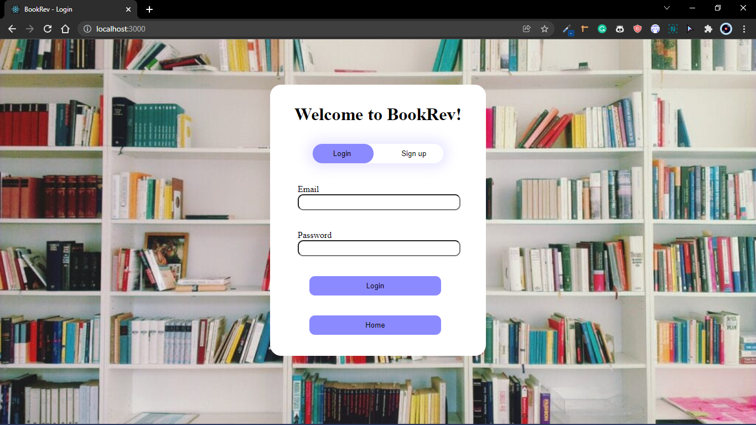

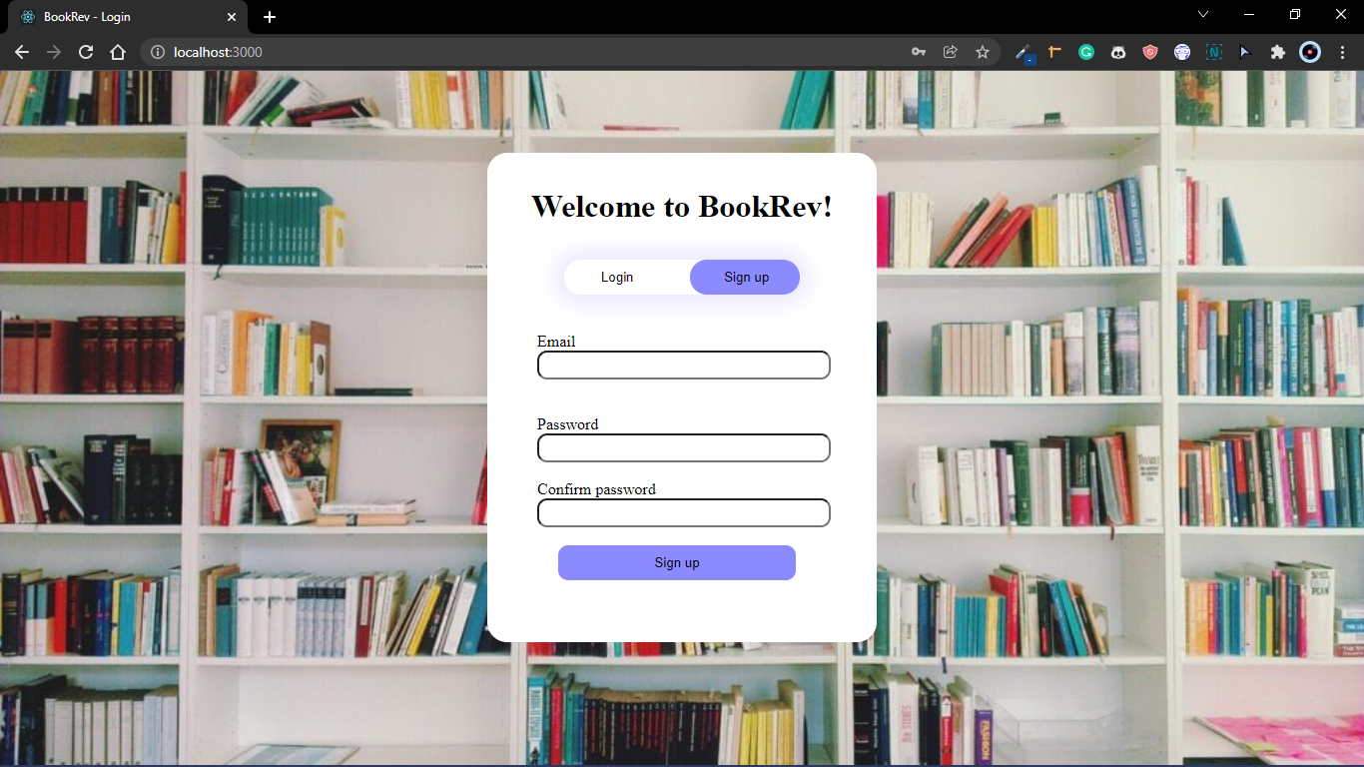

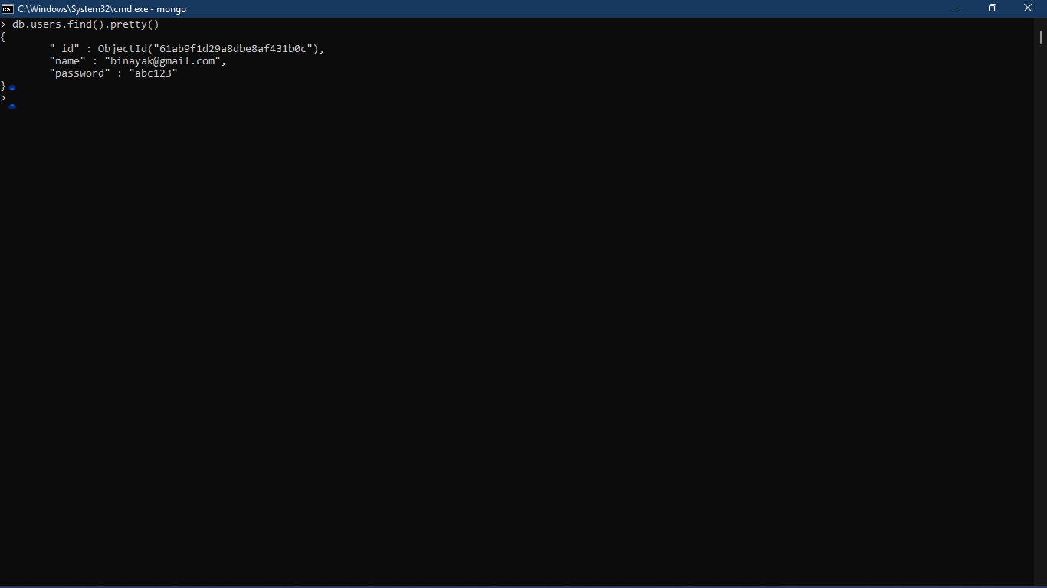

**Login/Signup form + data stored on MongoDB**

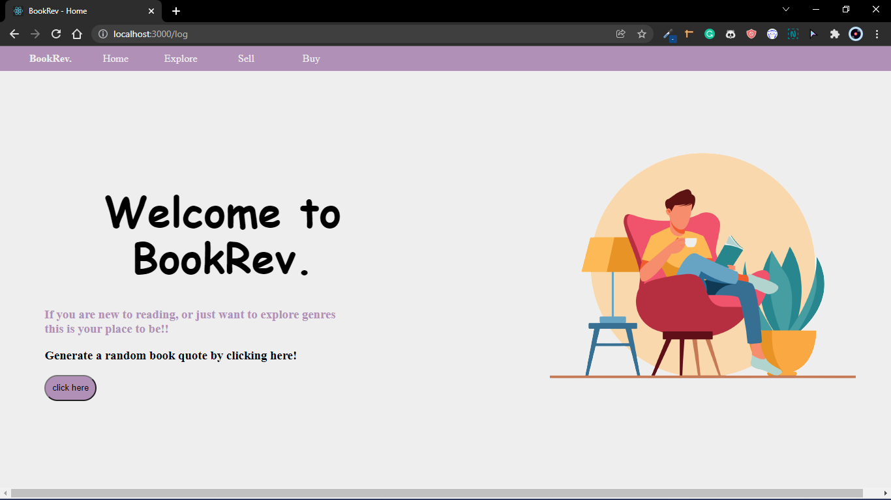

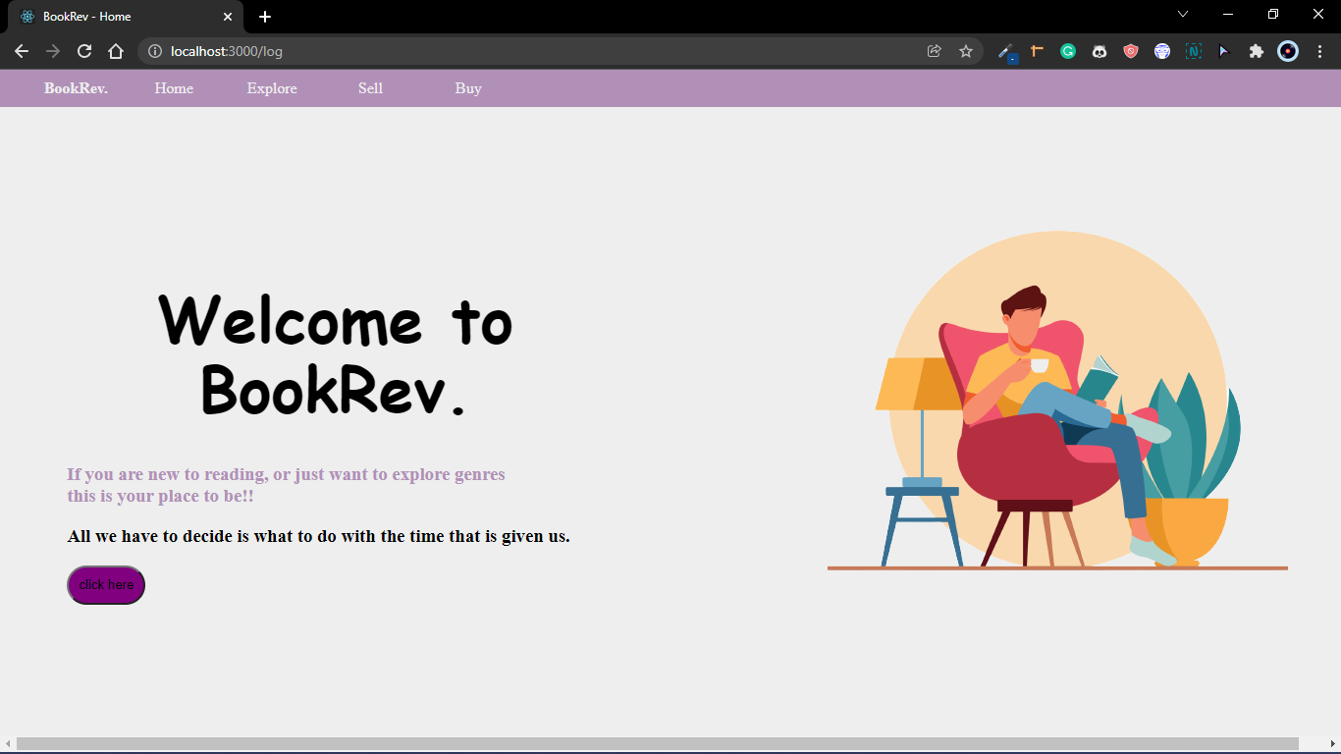

**Welcome page with random quotes**

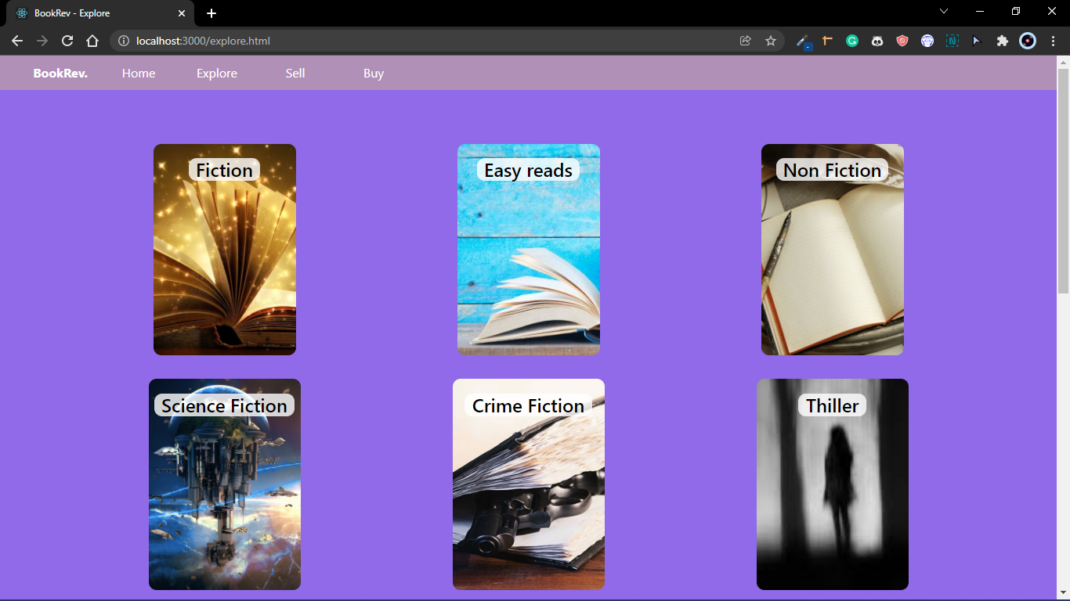

**Explore page**

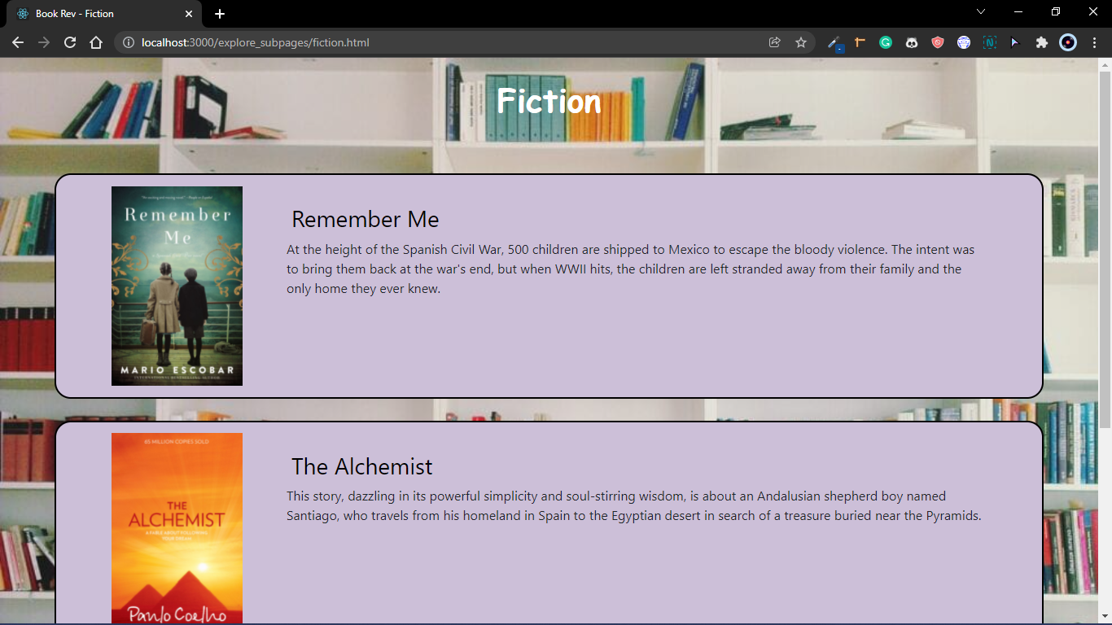

**Fiction genre page**

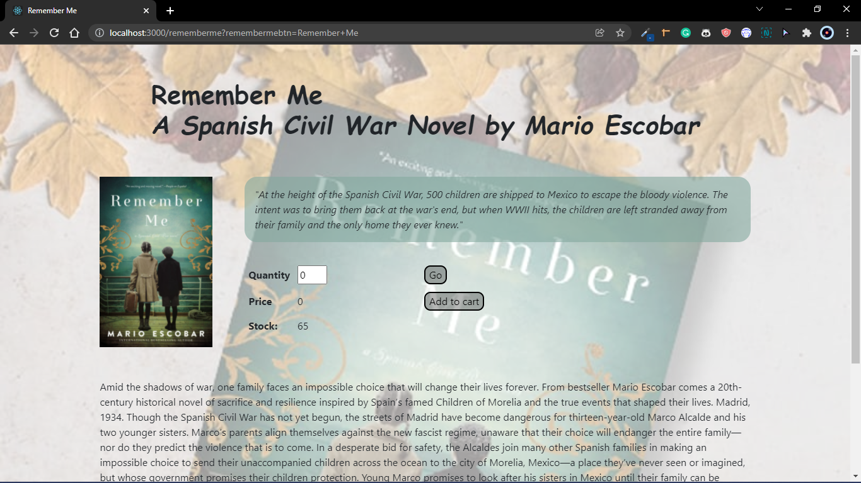

**Book page (1)**

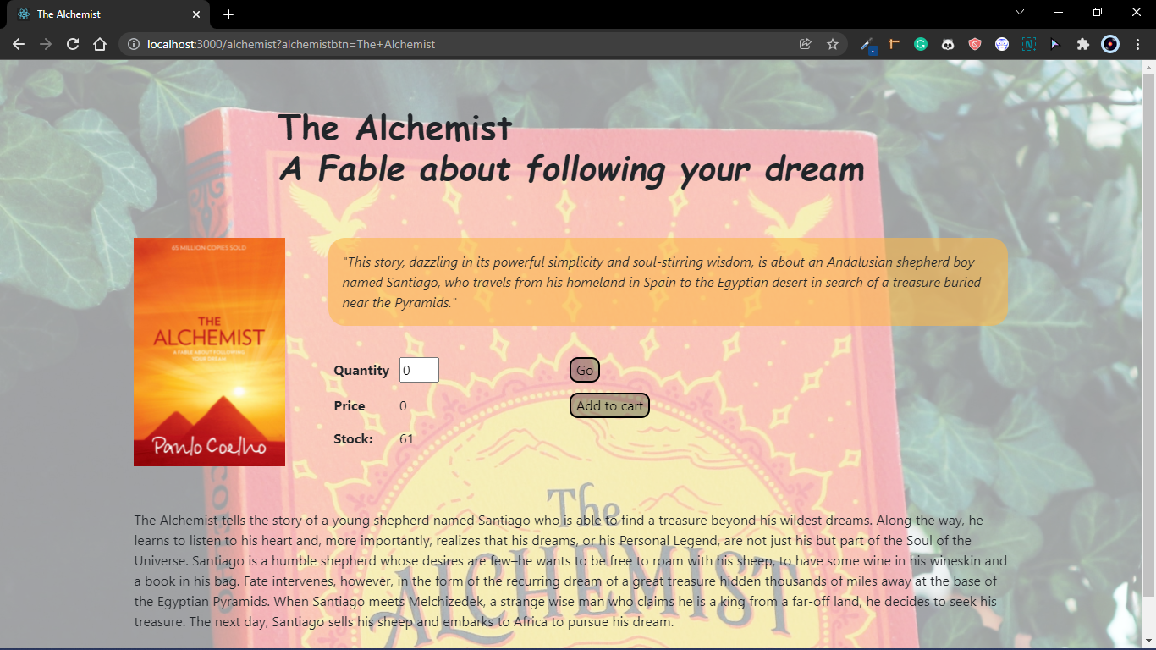

**Book page (2)**

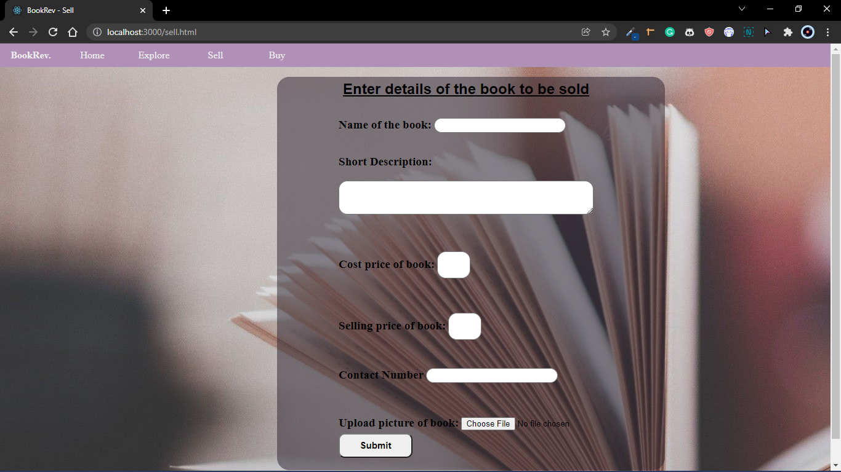

**Sell form**

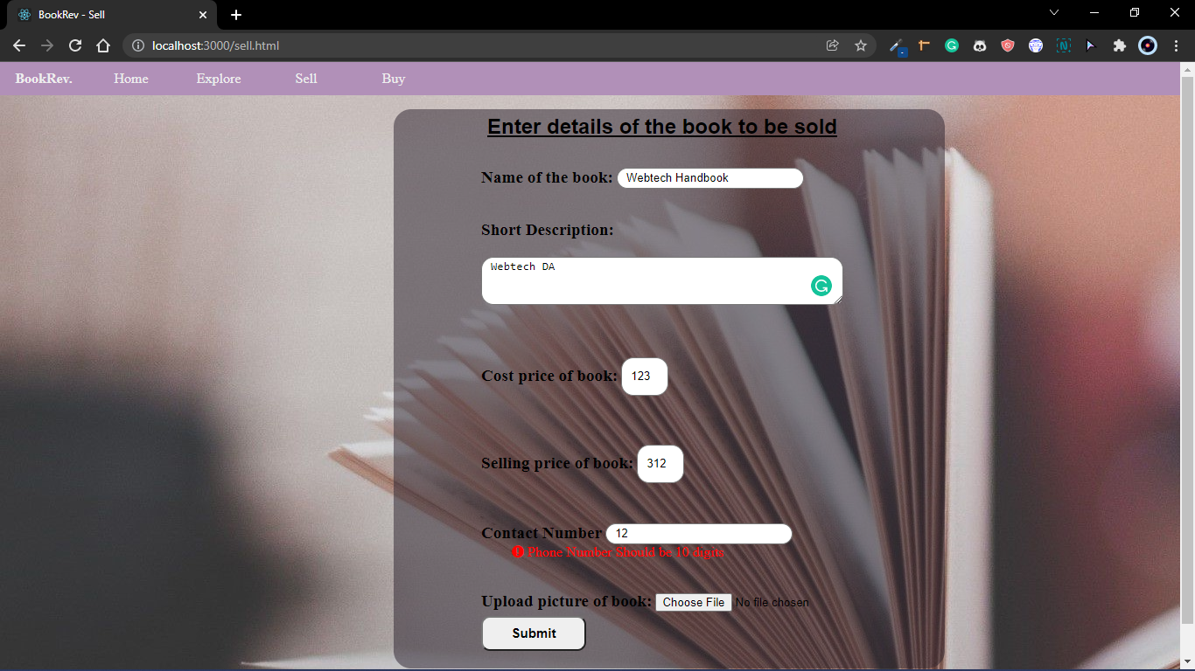

**Sell form validation**

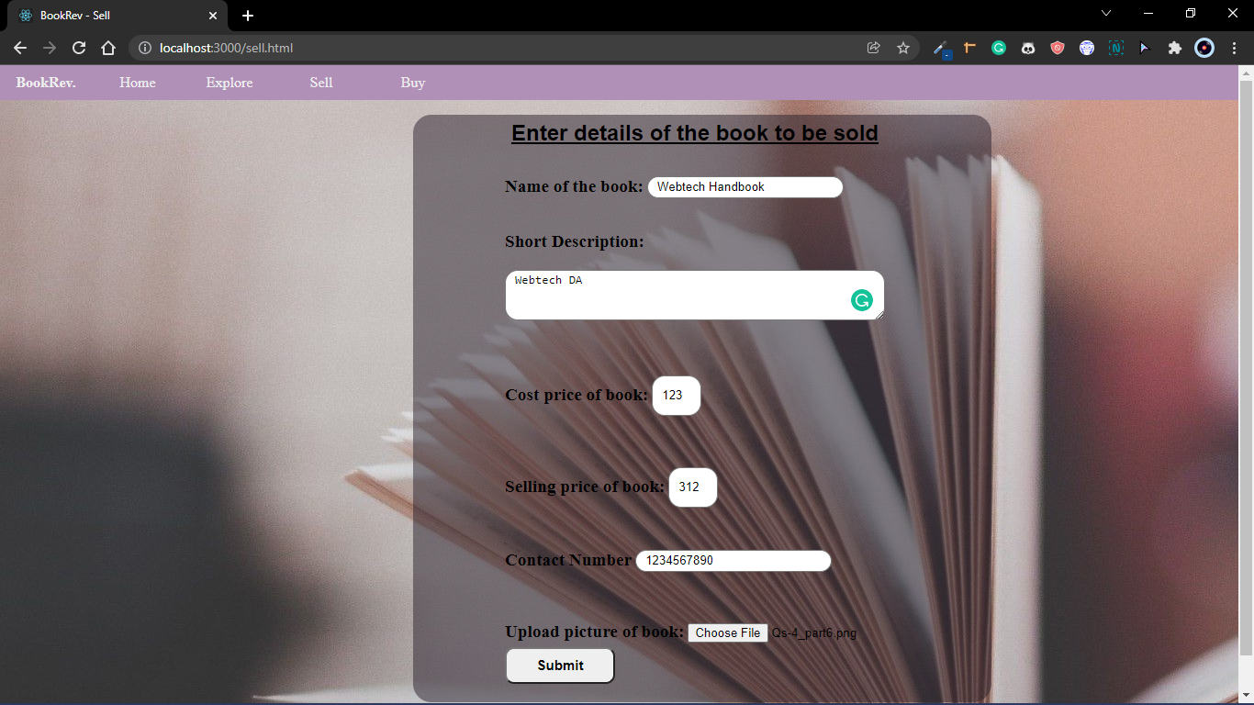

**Sell form input**

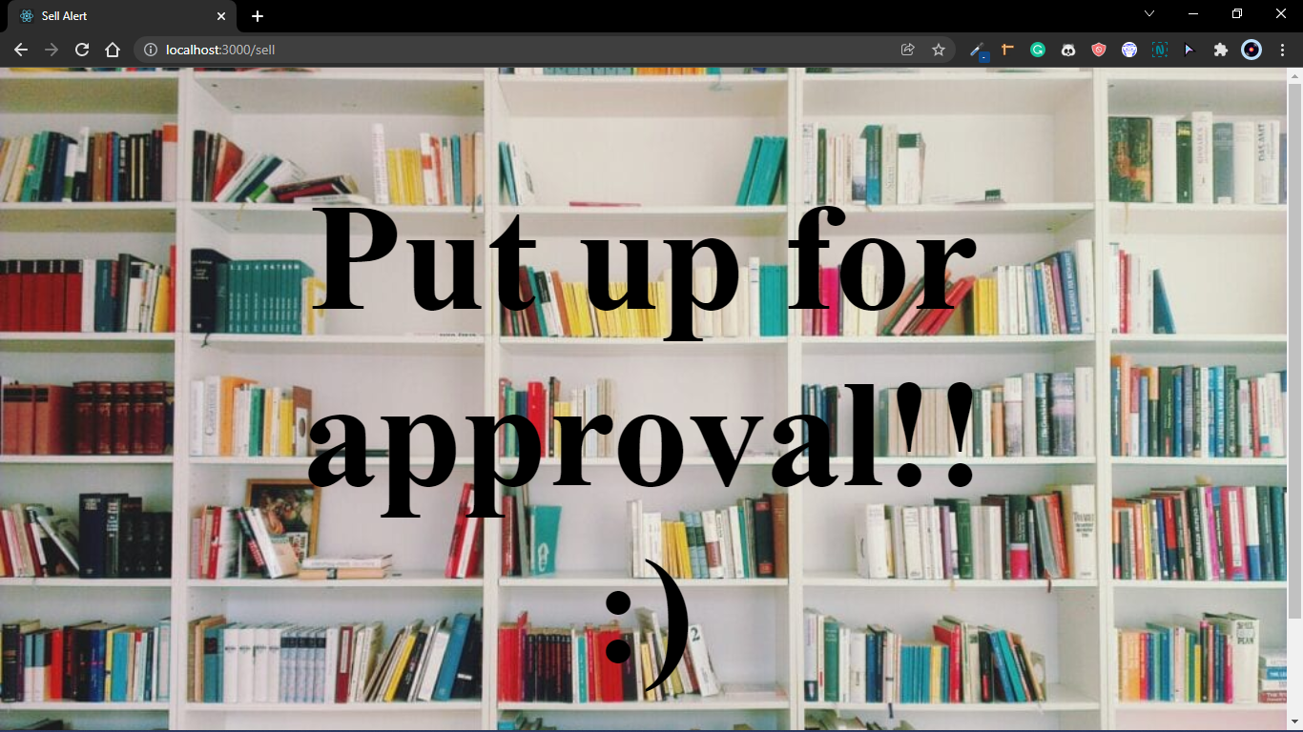

**Approval window for sell**

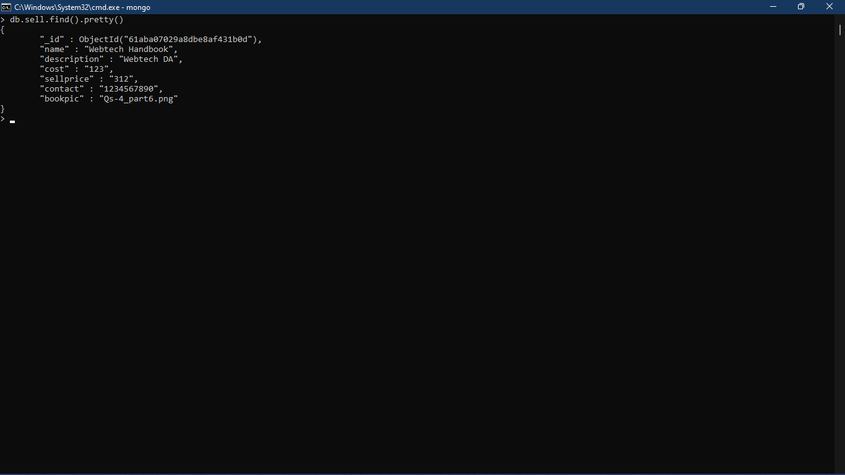

**Data from sell form stored**

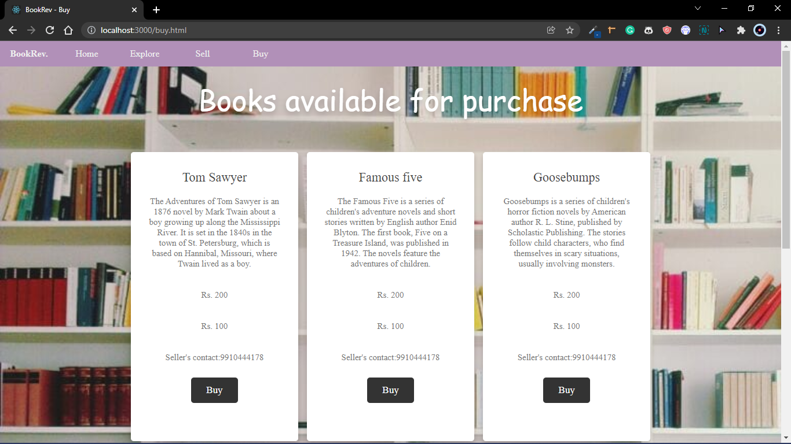

**Buy page**

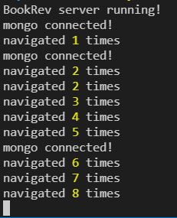

**Session tracking to see number of times page was visited**